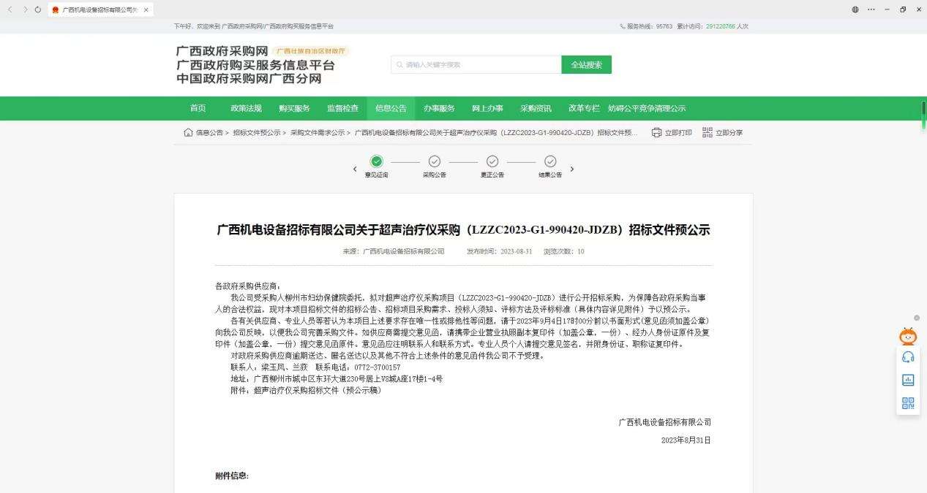广西政府采购网预公示链接：<http://zfcg.gxzf.gov.cn/luban/detail?parentId=66485&articleId=ann_1ZnqOFokYj8OgBUZw/EzVtD5ndTMr3NGt5TILBJnhQo=&utm=app-announcement-front.777aa7f9.0.0.9e08794047cc11eebd305d793828f95b>

广西柳州政府采购网预公示链接：http://zfcg.lzscz.liuzhou.gov.cn/luban/detail?parentId=138102&articleId=ann_1ZnqOFokYj8OgBUZw/EzVtD5ndTMr3NGt5TILBJnhQo=&utm=app-announcement-front.777aa7f9.0.0.9e08794047cc11eebd305d793828f95b