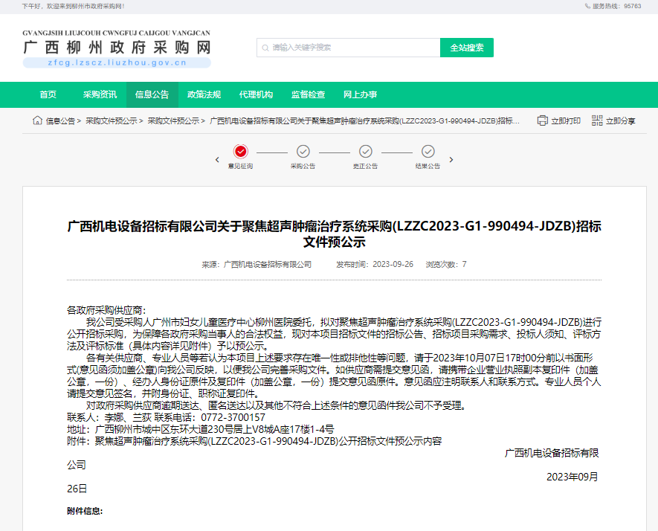

广西政府采购网：<http://zfcg.gxzf.gov.cn/luban/detail?parentId=66485&articleId=ann_H7pHp+jLQO6Qd/biCtiWx9D5ndTMr3NGt5TILBJnhQo=&utm=app-announcement-front.777aa7f9.0.0.09aaef805c3a11ee8280af3fdcc80401>

柳州政府采购网：<http://zfcg.lzscz.liuzhou.gov.cn/luban/detail?parentId=138102&articleId=ann_H7pHp+jLQO6Qd/biCtiWx9D5ndTMr3NGt5TILBJnhQo=&utm=app-announcement-front.777aa7f9.0.0.09aaef805c3a11ee8280af3fdcc80401>