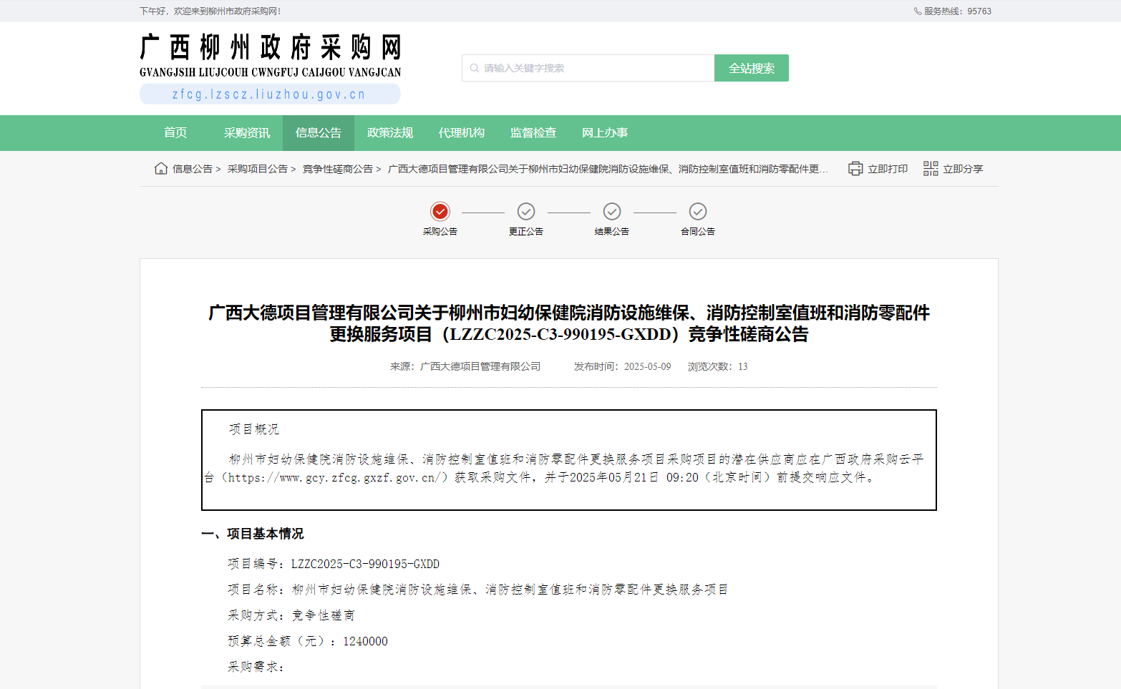
http://zfcg.lzscz.liuzhou.gov.cn/site/detail?parentId=138102&articleId=tAzh+yuHT3CvWNZmsdFUaA==&utm=site.site-PC-42120.1024-pc-wsg-secondLevelPage-front.1.1041cc302cac11f08f43eb88a849d0d2

