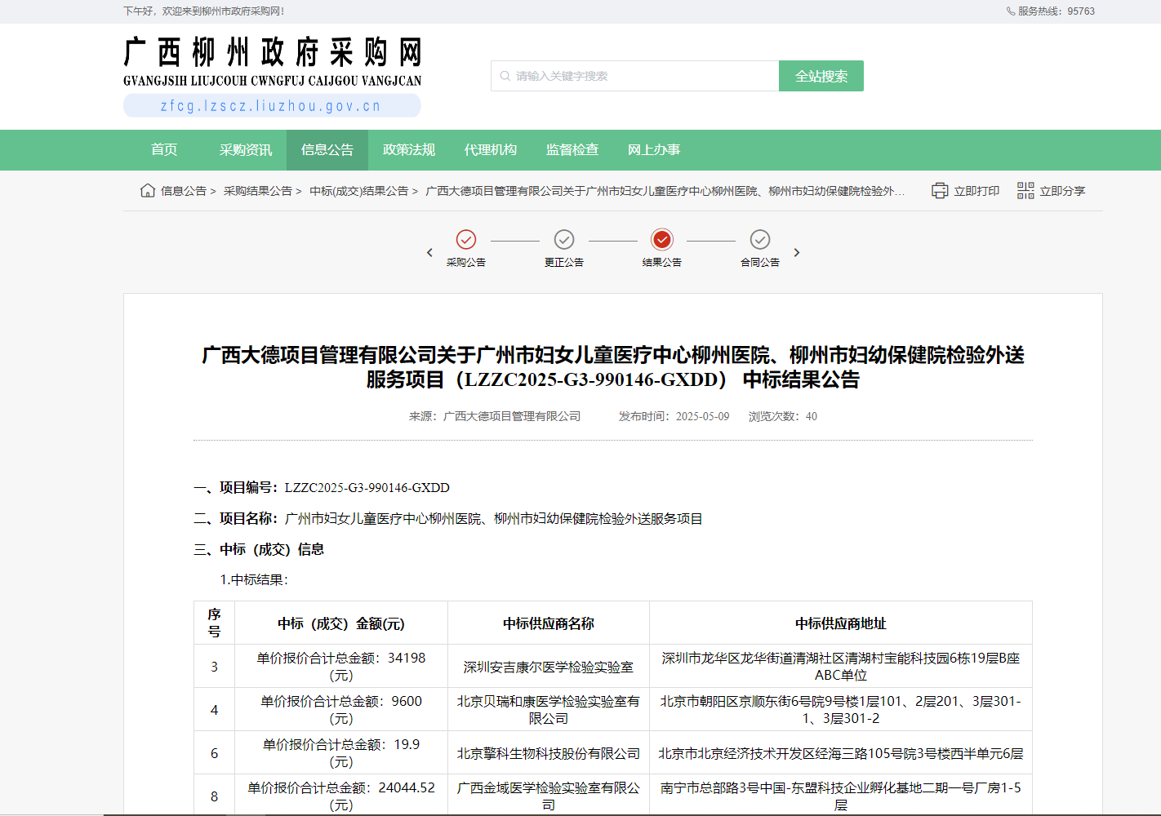
http://zfcg.lzscz.liuzhou.gov.cn/luban/detail?parentId=138102&articleId=ann_bhAzL8/kXkTxZpOLdwgaPdD5ndTMr3NGt5TILBJnhQo=&_app_=zcy.procurement.cgr.entrust

