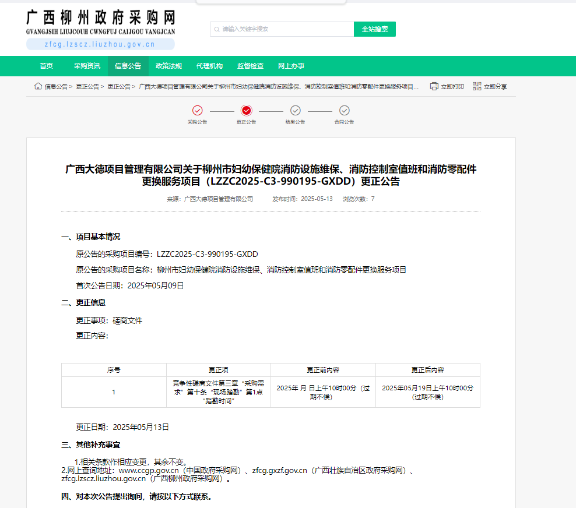

链接：http://zfcg.lzscz.liuzhou.gov.cn/site/detail?parentId=138102&articleId=GMD1cDHOFw+CLOsE177qdQ==&utm=site.site-PC-42049.1069-pc-wsg-ArticlePurchaseNoticeList-front.2.955c0a902fa211f082d00fd15215ebd0