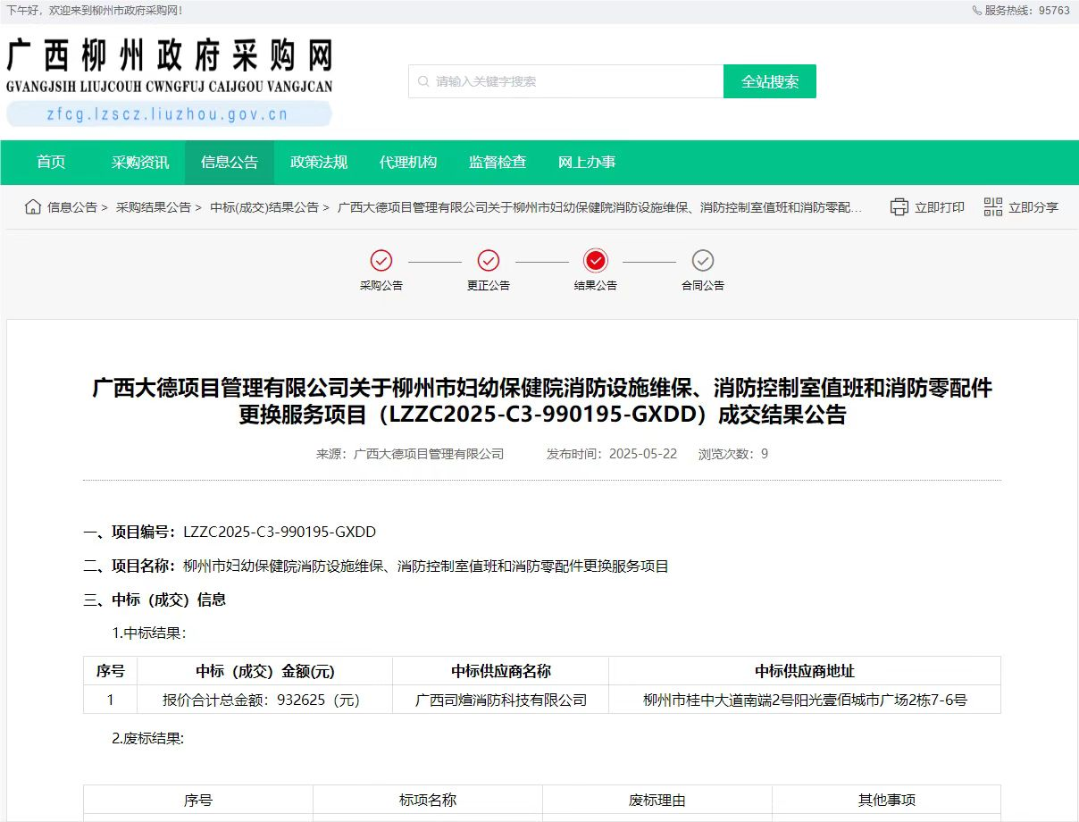

连接:http://zfcg.lzscz.liuzhou.gov.cn/site/detail?parentId=138102&articleId=BpuPL9QVQlicKzeYk4hIrA==&utm=site.site-PC-42049.1069-pc-wsg-ArticlePurchaseNoticeList-front.17.84a9606036a211f085a529b07dbf86a8