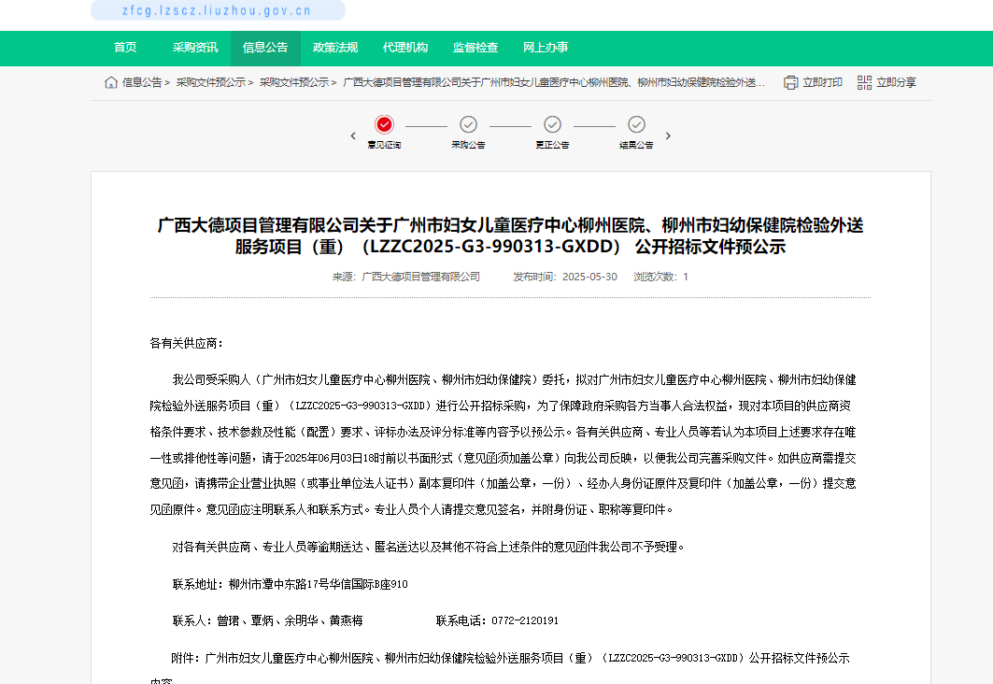http://zfcg.lzscz.liuzhou.gov.cn/site/detail?categoryCode=ZcyAnnouncement&parentId=138102&articleId=oO5AJgpuaFOdjQO46JkIwQ==&utm=site.site-PC-42138.1045-pc-wsg-mainSearchPage-front.2.eb96e3903d3911f083bc5d31c10bbbae

