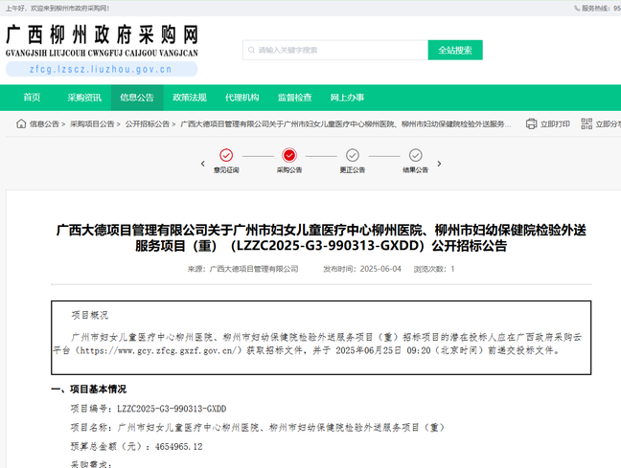链接：http://zfcg.lzscz.liuzhou.gov.cn/site/detail?parentId=138102&articleId=GfdzbP8SFhGk573vVHXq4g==&utm=site.site-PC-42049.1069-pc-wsg-ArticlePurchaseNoticeList-front.2.80f50cb040ef11f0ab603740af2b28e0