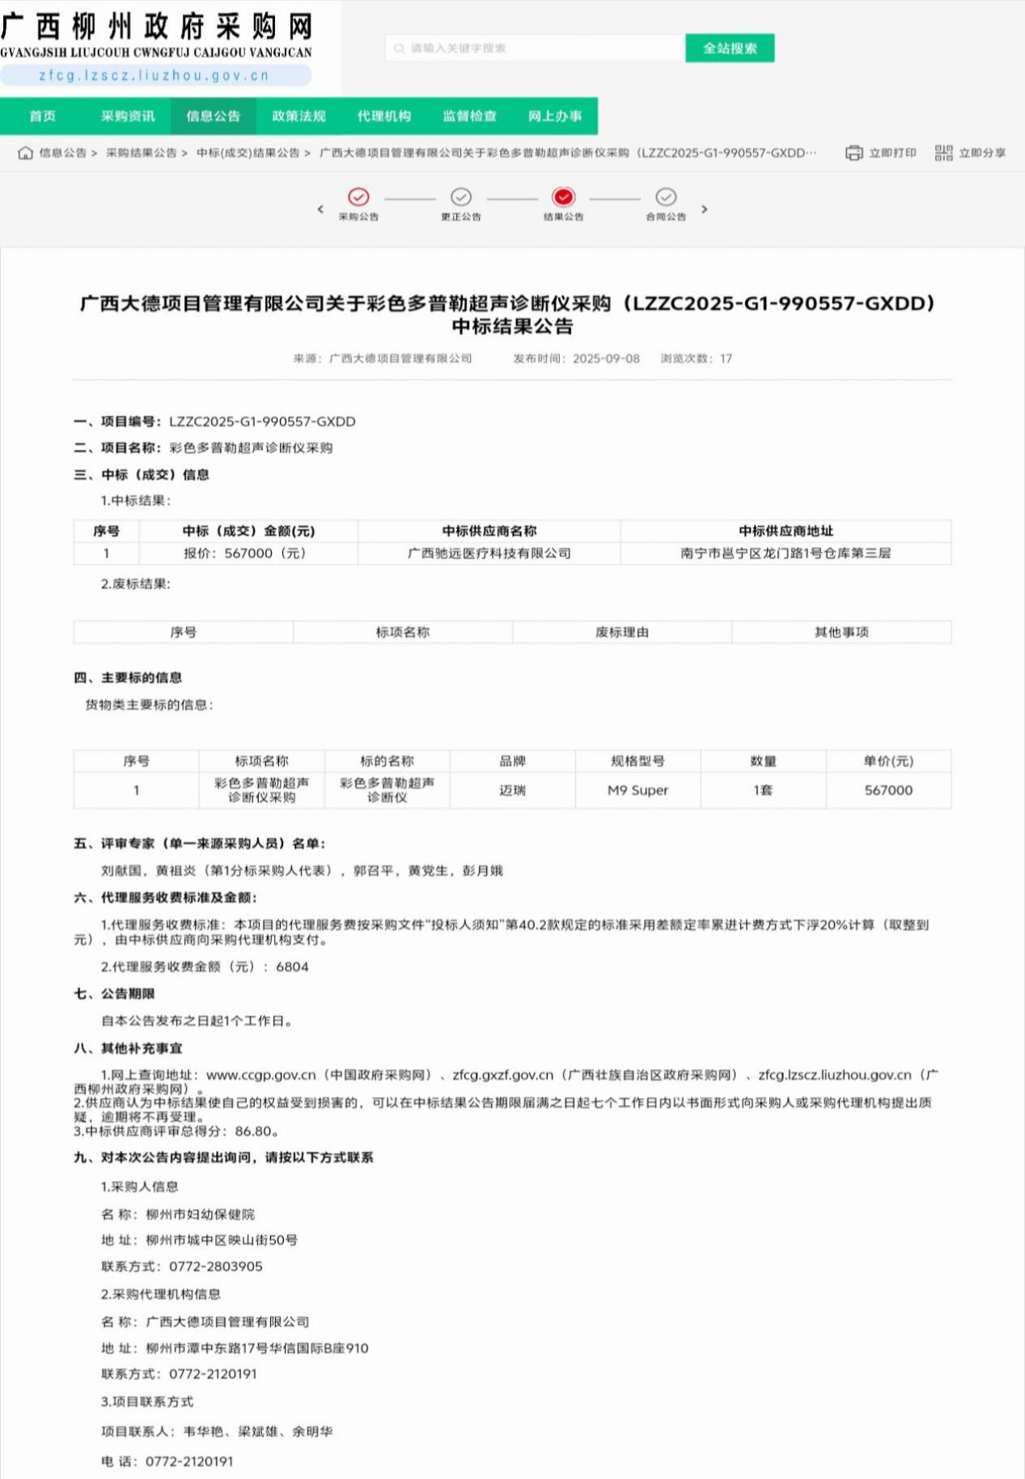http://zfcg.lzscz.liuzhou.gov.cn/site/detail?parentId=138102&articleId=DNEACtUPcJ8Ovj6a96sikg==&utm=site.site-PC-42120.1024-pc-wsg-secondLevelPage-front.1.9d0259b08c7311f0b01f87c4a11d464c