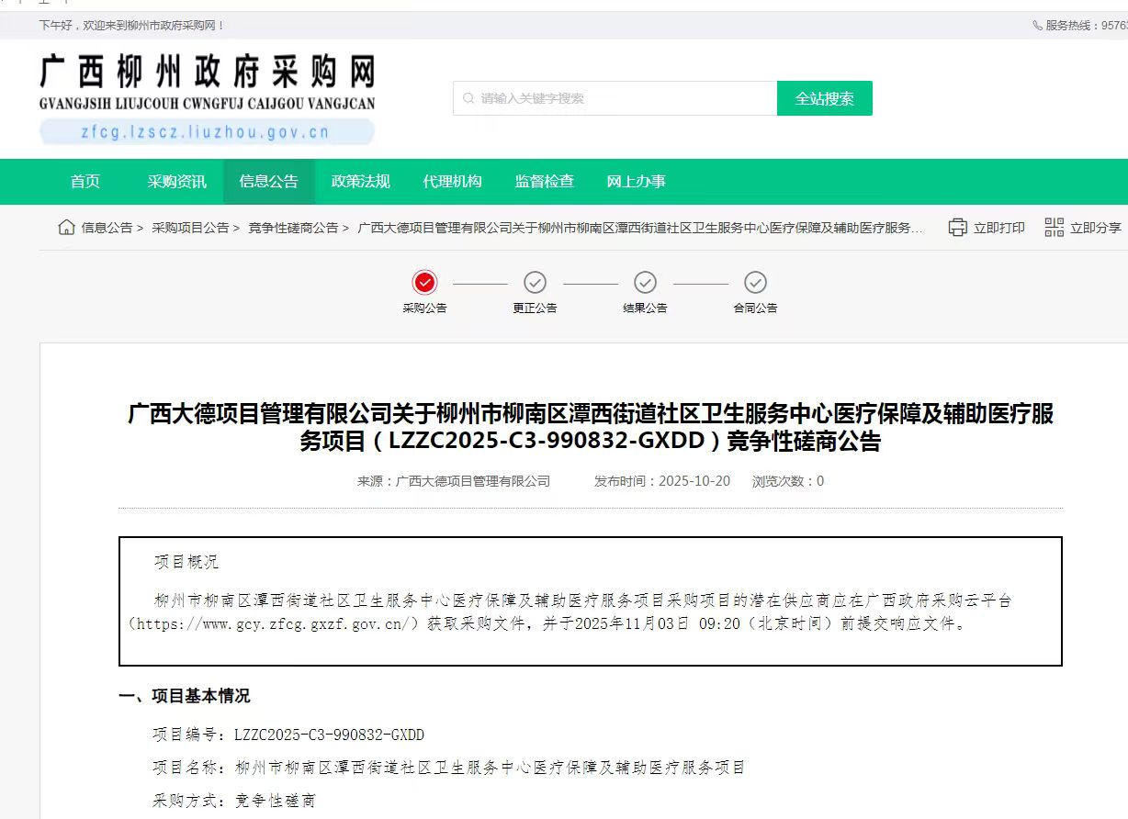

链接：http://zfcg.lzscz.liuzhou.gov.cn/luban/detail?parentId=138102&articleId=ann_SY2LW1spCC0+xn1IyYpP9tD5ndTMr3NGt5TILBJnhQo=&utm=app-announcement-front.43dc720f.0.0.8ad9e960ad9311f09f0da5e56b0f23c2