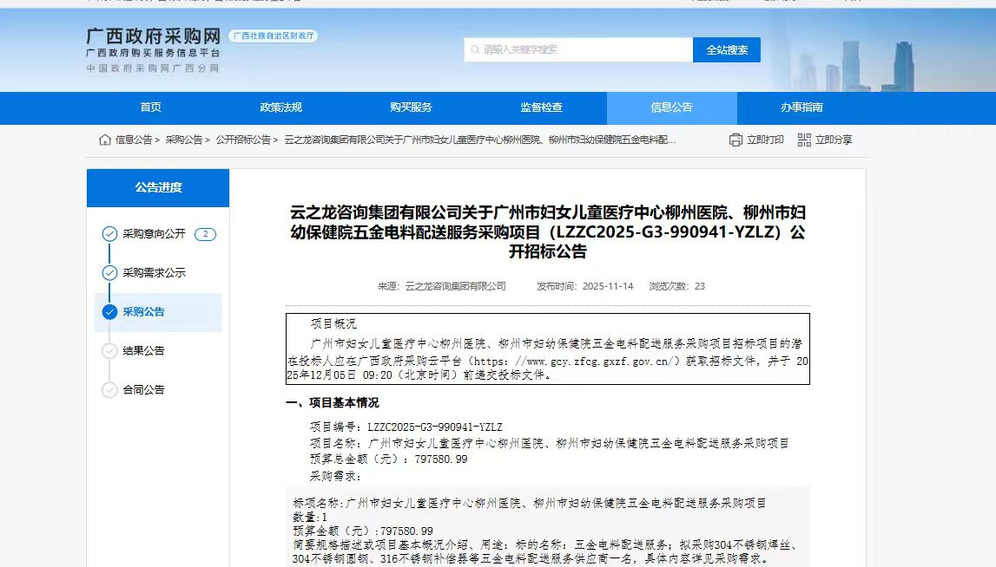
链接：https://zfcg.gxzf.gov.cn/luban/detail?parentId=66485&articleId=ann_uSAYs7tptMC7luIddid0WdD5ndTMr3NGt5TILBJnhQo=

